MXN442: Assignment 2 Report

Selected Paper Title: Hybrid CNN-BiLSTM Model with HHO Feature Selection for Enhanced Fake News Detection (Jain et al., 2025)

Name: Fahad Thakur
Student ID: 11997575

Introduction
Fake news can refer to both misinformation or even disinformation, spread on the internet through social media or even aired by traditional new media (National Library of Australia, 2023). These fake news aim to propagate propaganda, create clickbait, or even cause conspiracies amongst the community. In today’s world where we are deeply connected with each other through the internet, it becomes very easy to view and even believe in this fake news. This has potential to harm lives and poses a threat to society (Jain et al., 2025).
The primary challenge that the authors of the paper mention is that linguistic feature selection has often been overlooked. The authors aim to overcome feature redundancy by using an optimization technique that selects the optimal linguistic features from a larger set. The Harris Hawks Optimization (HHO) algorithm has been used by the authors as the feature selector. By leveraging these selected features, they aim to build a more accurate and generalizable model using a CNN-BiLSTM hybrid.
The objective of this assignment is to replicate the performance of the research article using methods that were used in MXN442. As such, this assignment implements the use of logistic regression, SVM, and an XGBoost Classifier as the main methods. The dataset and linguistic features used have been provided by the authors of the paper.

Data
The datasets used and the linguistic features have been provided by the authors of the paper. For this assignment, only 2 of the 4 datasets have been considered. Both datasets consist of title, text and a label (0 = genuine, 1 = fake news).

McIntire Dataset
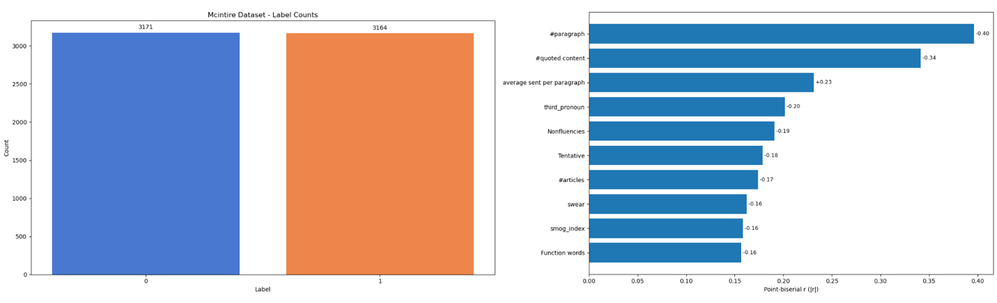
Figure 1: McIntire Dataset Features
The McIntire dataset consists of 6,335 records of data mostly news articles from the 2016 US presidential elections. The dataset is fairly balanced between genuine and fake articles, ensuring that any models trained on this dataset would not be biased towards either of the class labels.
A negative correlation between the number of paragraphs, quoted content with the article being fake can be seen in the plot above. The plot also shows that an increase in the average sentences per paragraph leads to a higher correlation with it being fake news.

Kaggle Dataset
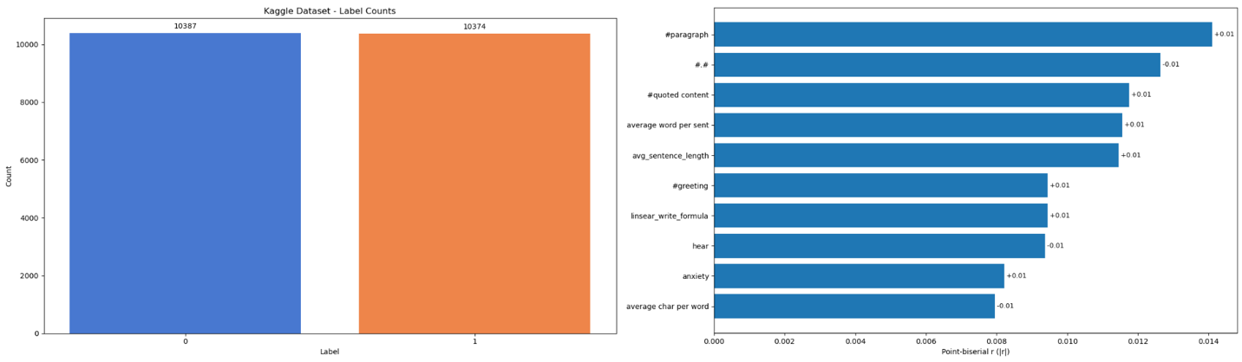
Figure 2: Kaggle Dataset Features
The Kaggle dataset is a much larger corpus of data, consisting of 20,761 records of data from real-word outlets in different domains. The dataset is also well-balanced between genuine and fake article labels.

Methodology
The authors of the paper preprocess their datasets and then extract its linguistic features. They implementation the HHO algorithm (refer Figure 3) to pick the most informative subset of features. Then a Word2Vec model extracts word embeddings from the dataset which is then combines with the selected linguistic features. The authors then train and evaluate their model individually on each dataset.
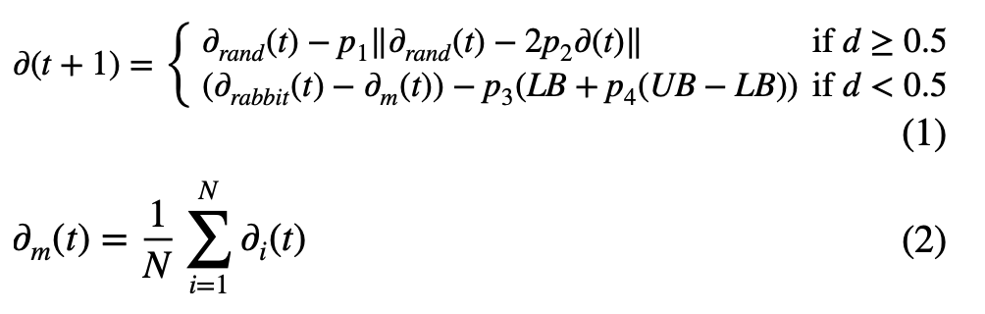
Figure 3: HHO Algorithm Used by the Paper

Preprocessing
The preprocessing implemented for this assignment follows the similar strategy adopted by the paper. This includes normalizing the text and converting to lowercase. Then removing URLs and special characters. The words are then tokenized using the NLTK tokenizer. Finally, stop words are removed and the words are converted to their base form using a technique called lemmatization. These preprocessing steps ensure that the same linguistic feature set can be used to train and evaluate the models for this assignment.

Model Implementation
The models were implemented using 2 separate approaches – Word2Vec Approach, TF-IDF Vectorizer Approach.
Word2Vec Approach: This is the approach that the authors of the paper use. It is a shallow CNN model that works by creating a vector space in which words with semantically similar meaning are placed closed together (TensorFlow, 2024). The vector size has been set to 100, with a window of 5 and a minimum count of 1.
TF-IDF Vectorizer Approach: The TF-IDF vectorizer converts the text into a matrix of TF-IDF features (Scikit learn, 2018). It works by weighting the word based on its frequency in the document and its frequency in the entire collection. The max_features was set as 5000.
The following main models have been implemented for this assignment. For each of these, 4 models have been trained in total, one for each of the approach and dataset mentioned above.
Logistic Regression: The logistic regression model from scikit learn has been implemented. A random state of 42 and max iterations of 1000 has been set as the default value. The scikit learns logistic regression method can implement L1/L2 regularization to reduce the impact of the correlated linguistic features.
$$P\left(Y=Fake News | X\right)=\frac{1}{1+e^{-(β_{0}+β_{1}X_{1}+…+β_{k}X_{k})}}$$
SVM: These models maximize the margin between the classes either through a linear kernel or a radial kernel. They work better on TF-IDF features due its sparse cues. Scikit learn’s SVM model has been implemented with a random state of 42 as the default parameter.
XGBoost Classifier: This model uses gradient boosted trees; it is good at capturing non-linear relationships in the linguistic features and embeddings of the datasets by using an ensemble of trees. A random state of 42, and an evaluation metric of log loss was used which is common for binary classification tasks.
These models were chosen as they are well known for their effectiveness in performing binary classification task. Models such as logistic regression and SVM are often used as a baseline by researchers developing and evaluating deep-learning models.

Optimization & Cross-Validation
To optimize the hyper-parameters of the chosen models, a GridSearchCV was set up with 5-fold cross-validation. The following hyper-parameters were considered:
Logistic Regression: C: [0.01, 0.1, 1, 10, 100], Penalty: [‘l1’, ‘l2’]
SVM: C: [0.1, 1, 10], Kernel: [‘linear’, ‘rbf’]
XGBoost Classifier: N_estimators: [50, 100, 200], Max_depth: [3, 5, 7]
The table below shows the hyper-parameters selected for each model.
Table 1: Hyper-parameters Selected
Dataset & Approach | Logistic Regression | SVM | XGBoost
McIntire W2V Model | C = 1, Penalty = L2 | C = 10, Kernel = RBF | N_estimators = 200, Max_depth = 7
McIntire TF-IDF Model | C = 100, Penalty = L2 | C = 1, Kernel = Linear | N_estimators = 200, Max_depth = 5
Kaggle W2V Model | C = 100, Penalty = L2 | C = 10, Kernel = Linear | N_estimators = 200, Max_depth = 3
Kaggle TF-IDF Model | C = 100, Penalty = L2 | C = 10, Kernel = Linear | N_estimators = 200, Max_depth = 3
The McIntire dataset is relatively smaller, and it contains almost similar type of articles, i.e., 2016 US election news articles. Hence the logistic regression model uses a stronger regularization value (C=1), and the SVM model uses an RBF kernel. Kaggle models have a lower max_depth for the XGBoost models. This shows a better generalization capability.

Evaluation Techniques
The models were evaluated using accuracy, AUC score, plotting confusion matrices, and finally very briefly touching on an out-of-distribution (OOD) generalization check.

Results

McIntire Dataset
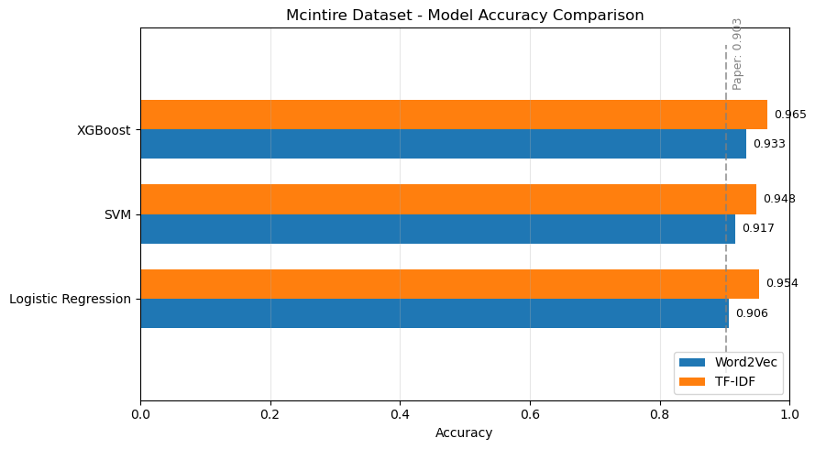
Figure 4: McIntire Dataset Model Performance Comparison
- From the figure above, we can see that the paper’s report accuracy on the McIntire dataset is 90.26%.
- All the 3 models implemented outperform the paper’s accuracy with the highest being the XGBoost model trained using the TF-IDF approach (accuracy = 96.5%), closely followed by the logistic regression model using the TF-IDF approach (accuracy = 95.4%).
- In general, the TF-IDF approach outperforms the Word2Vec approach that was used by the paper. This is because TF-IDF vectorization preserves the specific phrase markers and has sparse cues that models such as the XGBoost can isolate better.
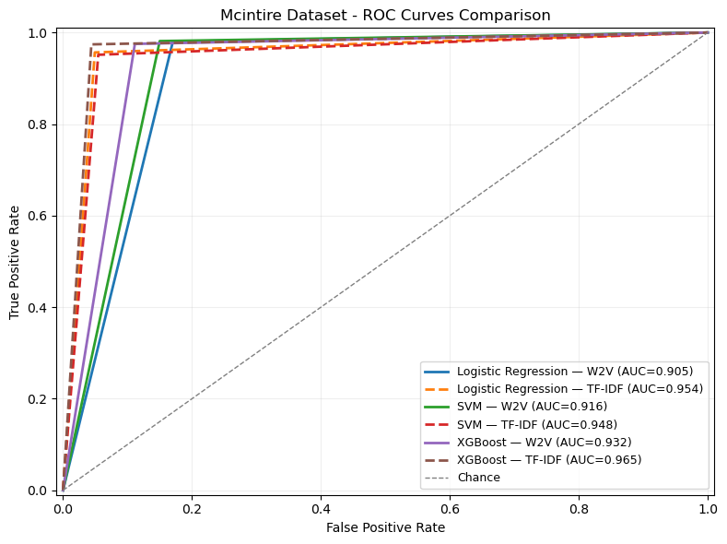
Figure 5: McIntire Dataset Model ROC Curves Comparison
- Figure 5 above shows the ROC curves comparison, the y-axis is the true positive rate (also known as recall or sensitivity). The x-axis is the false positive rate, or the proportion of genuine news article that were classified to be fake news.
- The ROC curves once again show cases that the XGBoost with TF-IDF approach performs the best.
- Additional performance metrics such as the confusion matrices can be viewed from the ipynb notebook in the GitHub repository attached in the appendix below.

Kaggle Dataset
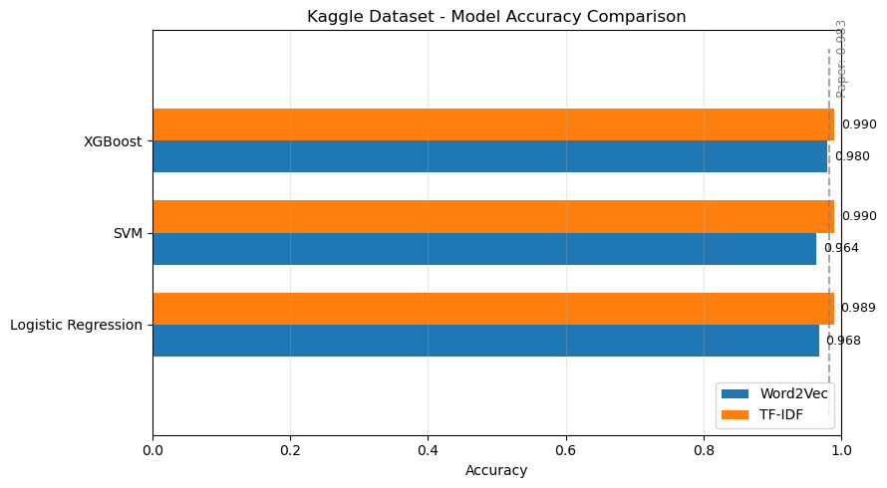
Figure 6: Kaggle Dataset Model Performance Comparison
- The authors of the paper reported an accuracy of 98.25% for this dataset. They achieve a higher accuracy than the models using the Word2Vec approach.
- When the models use the TF-IDF approach, it receives better accuracy than the paper’s reported accuracy (XGBoost/SVM 99.0% acc). Once again, this shows the benefits of using a TF-IDF approach.
- Despite being much simpler models, they outperform the paper’s CNN-BiLSTM hybrid. This is because the logistic regression, SVM, and XGBoost models when trained with the TF-IDF features are more effective at handling these structured data.
- Additional performance metrics such as the confusion matrices can be viewed from the ipynb notebook in the GitHub repository attached in the appendix below.
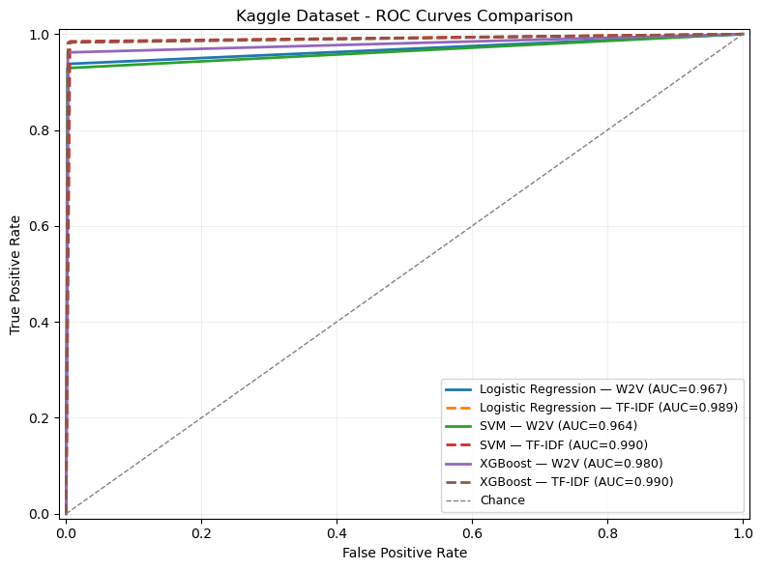
Figure 7: Kaggle Dataset Model ROC Curves Comparison

Discussion
ChatGPT 5 with extended thinking was used to try to ideate and implement solutions to improve the performance of the paper. All prompts and responses can be found in the appendix link.

Figure 8: Initial ChatGPT Prompt
ChatGPT was prompted for providing solution ideas either through preprocessing, feature extraction, or other models. The prompt introduced the article, and what was not needed as a solution. The following are the solutions provided by ChatGPT:
- Implement a document-aware transformer method using a fine-tuning approach. It was suggested that these transformer-based models can better capture long-range dependencies that are seen in textual data better than the CNN-BiLSTM hybrid model of the paper.
- The second solution was to keep the architecture of the paper, but to add a multi-head self-attention pooling on top of the BiLSTM. This would help surface salient spans of characters in the text.
- ChatGPT also suggested solutions to improve the cross-dataset generalization by implementing a domain-adversarial training technique (DANN).
- Replacing the HHO feature selector for a differentiable/stable feature selector was also suggested.

Implementing GenAI’s Solution
The transformer-based model was chosen to be implemented entirely by prompting ChatGPT by “vibe-coding”. This gave a multimodal binary classifier that fuses RoBERTa text features with the dataset’s linguistic features.
The article text is tokenized using RoBERTa tokenizer (max_length=510) and the CLS embedding passes through Dropout(0.2) followed by a Dense(768, GELU). The linguistic features pass through LayerNorm followed by Dense(128, GELU), then Dropout(0.3), and finally Dense(128, GELU). A late fusion-derived sigmoid gate (Dense 768) FiLM-modulates the text vector, which is then concatenated with the linguistic feature vector and fed to Dropout(0.3), Dense(256, GELU), Dropout(0.3), Dense(1) and finally Sigmoid for the final probability.
This model was trained with binary cross-entropy (label smoothing 0.05), metrics ROC-AUC/PR-AUC/Precision/Recall/F1/Accuracy, and Adam using a warmup-cosine schedule (lr_max=2e-5, warmup=500, total=5000, clipnorm=1.0, decay=0.01). Training is two-phase: 2 epochs with the transformer frozen, then 5 epochs unfrozen, using early stopping (patience=2 on val AUC) and checkpointing the best weights. The model was trained on the McIntire dataset as transformer-based models are resource intensive, and just training on the smaller McIntire dataset itself took over 6 hours. The code for this can be found in the ipynb notebook in the GitHub repository.
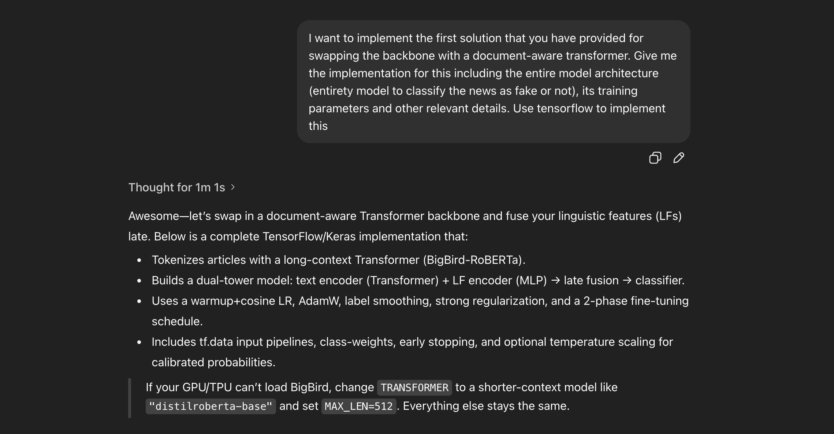
Figure 9: ChatGPT Prompt to Implement Transformer Solution
As seen in Figure 10 below, the model provided by ChatGPT performed almost perfectly achieving an accuracy of 99.68% on the McIntire test set and getting on 2 misclassifications. This is indicative of the benefits of the using a transformer-based model to learn long-range dependencies that are seen in textual data.
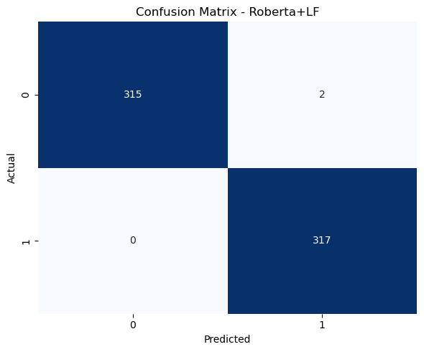
Figure 10: Transformer-Based Model Performance on McIntire Test Set
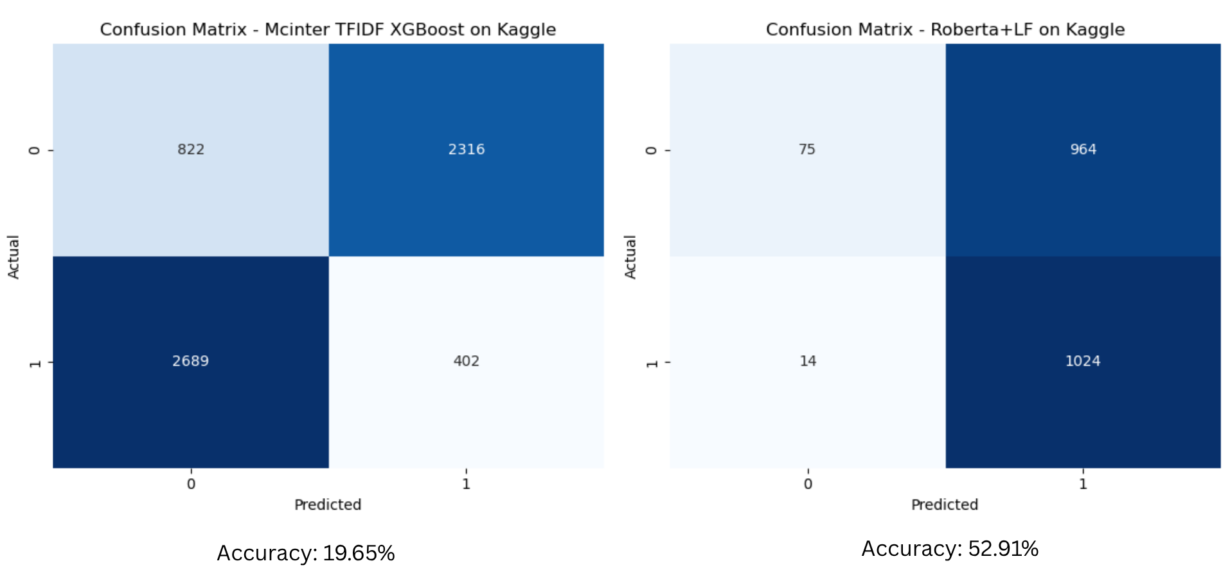
Figure 11: OOD Generalization Check McIntire TF-IDF XGBoost Model vs McIntire Transformer-Based Model
The OOD generalization check done on the Kaggle dataset further showed the benefit of using a transformer-based model with textual data to detect fake news. The transformer-based model achieved more than double the accuracy (52.91%) of the best model on the McIntire dataset. This can be considered a very positive result as generalization was not even considered when building and training the transformer-based model.

Benefits & Caveats of GenAI
ChatGPT performed exceptionally in giving ideas for solutions that can be implemented. It was also used to create the model performance comparison plots. However, it did hallucinate at times with regards to implementing the entire transformer-based solution by giving me parameters that don’t exist. It did provide me with things to do even though they are not recommended, such as giving an option to use the cleaned text instead of the raw text as the input to the Transformer model and giving more code than was needed.
Overall, the process of using ChatGPT to debug and fix code would not be recommended, as reading through official documentation and using Google to research and implement fixes is a much more straightforward and easier approach.
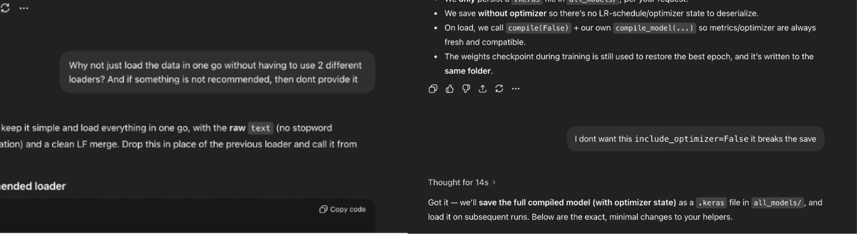
Figure 12: Code Correction Prompts

Conclusion
Logistic regression, SVM, and XGBoost Classifier models perform exceptionally well in detecting fake news from the McIntire and Kaggle datasets. Their performance is often comparable and at times even better than the performance of the CNN-BiLSTM hybrid model of the paper. The best performing model on the McIntire dataset was the XGBoost classifier with the TF-IDF approach, having an accuracy of 96.5%. On the Kaggle dataset, both the XGBoost and the SVM models using the TF-IDF approach achieved an accuracy of 99.0%. This highlights the benefits of using the TF-IDF approach as it preserves the specific phrase markers and creates more sparse cues which are better exploited by these simpler models.
GenAI did give several suggestions to further improve the performance of the paper. Following these suggestions, a transformer-based model was built and trained on the McIntire dataset. It performed almost perfectly, only misclassifying 2 news articles in the test set and achieved an accuracy of 99.68%. The model also performed modestly when testing its OOD generalization on the Kaggle dataset where it achieved an accuracy of 52.91%. This shows the benefits of using a transformer-based model to perform fake news detection through textual data and overall shows that the suggestions provided by GenAI was good.
Future improvements could be to train the model on a larger dataset and to implement the DANN suggestion provided by GenAI to improve the cross-dataset generalization of the transformer-based model. This would boost its effectiveness in real-world scenarios and make it more deployable for detecting fake news with confidence.

References
Jain, M. K., Gopalani, D., & Meena, Y. K. (2025). Hybrid CNN-BiLSTM model with HHO feature selection for enhanced fake news detection. Social Network Analysis and Mining, 15(1). https://doi.org/10.1007/s13278-025-01455-6
National Library of Australia. (2023). What is fake news, misinformation, and disinformation? | National Library of Australia (NLA). Library.gov.au. https://www.library.gov.au/research/research-guides-0/what-fake-news-misinformation-and-disinformation
Scikit learn. (2018). TfidfVectorizer. Scikit-Learn.org. https://scikit-learn.org/stable/modules/generated/sklearn.feature_extraction.text.TfidfVectorizer.html
TensorFlow. (2024, July 19). word2vec | Text. TensorFlow. https://www.tensorflow.org/text/tutorials/word2vec

Appendix
GitHub Repository: https://github.com/fahadthakur/mxn442-assignment2
ChatGPT Prompts: https://chatgpt.com/share/68f3bdba-64c8-8007-9608-8ca1b49faf4b

